What can you find out about mammals?
Characteristics | In local area
In other parts of the World | Strangest
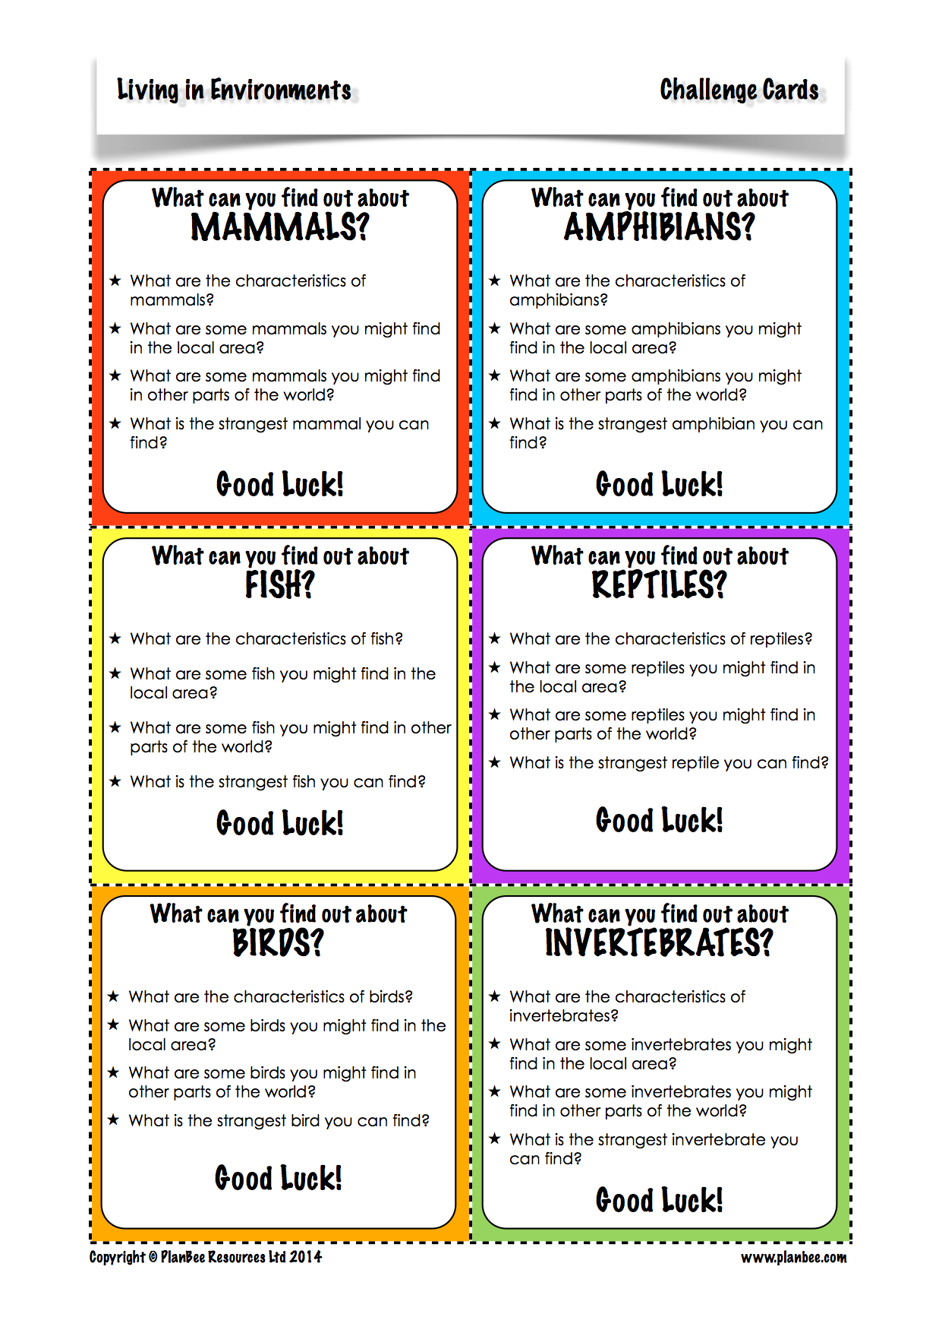

What can you find out about fish?
Characteristics | In local area
In other parts of the World | Strangest

What can you find out about birds?
Characteristics | In local area
In other parts of the World | Strangest

What can you find out about amphibians?
Characteristics | In local area
In other parts of the World | Strangest

What can you find out about reptiles?
Characteristics | In local area
In other parts of the World | Strangest

What can you find out about invertebrates?
Characteristics | In local area
In other parts of the World | Strangest

